

Dear Elthorne 1st Residents writing this I am aware that this is the last letter I will have the pleasure of writing for you. As some of you will be aware I am moving to pastures new. I just felt I wanted to take this opportunity of thanking all of you for the support and friendship you have shown me over the time I have spent working at Elthorne 1st. It has been great to feel such an integral part of the Elthorne 1st family. I’m certainly going to miss all the faces that have become so familiar to me over the years. Going forward I wish Elthorne 1st every success for the future and likewise to my successor and to coin a phrase of an old song, ‘Bonsoir old thing, cheerio chin chin! Nah-poo! Toodle-oo! Good..bye..ee!!!!

Neighbourhood Watch Scheme

You may have noticed the new Neighbourhood Watch signs along St. John’s Way, Partington Close, Mulkern and Duncombe Road. If having seen these you would like to be a part of this initiative, you can either fill in a form at the Co-Op Office or send an email to Elthorne1stNHW@elt-1st.co.uk.
Burglars can be very crafty and use all sorts of tricks to access your home including tools hidden up their sleeves, posing as contractors to name but a few. Sharing information about local crime activity allows us to keep you informed of whats going on, reduce crime and keep the estate safe. It is generally the case that crime reduction and crime prevention is more successful when everyone is involved so we would like to invite you to be a part of this initiative and support our local NHW scheme. If you would like a sticker for your door or window, please get in touch with Lorraine or in her absence leave a message on the Elthorne 1st Office answerphone and this can be arranged.
The next Neighbourhood Watch meeting is on:
Wednesday 14th November at 7.00 pm in the Elthorne 1st Co-Op Office (158 St. John’s Way, London, N19 3RL)
As our scheme is now registered we are in receipt of monthly newsletters from Islington Police which provide a summary of Islington Police and NHW news. These letters provide useful tips about Burglary Crime Prevention and other initiatives going on in the borough. If you are interested Copies will be available at the meeting on the 14th!
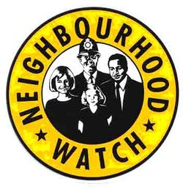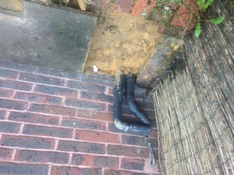
DON’T FORGET!! Neighbourhood Watch Meeting Wednesday 14th November in the Co-Op Office
at 7.00 pm

DATES FOR YOUR DIARY:

Next

Management Meeting of the Elthorne 1st Co-Op is on: Wednesday 21st November 2018 at 7.15 in the Co-Op office

Next General Meeting of the Elthorne 1st Tenant Co-Op is:
Wednesday 12th December 2018 stay to join us for pre-christmas refreshments once the meeting has finished and to meet our new Co-Op Manager Michelle Small.


.


158 St. John’s Way, London, N19 3RL
0207 263 5756 Info@elt-1st.co.uk

Autumn 2018
Elthorne 1st Tenant Co-Op
Autumn 2018
Elthorne 1st Newsletter

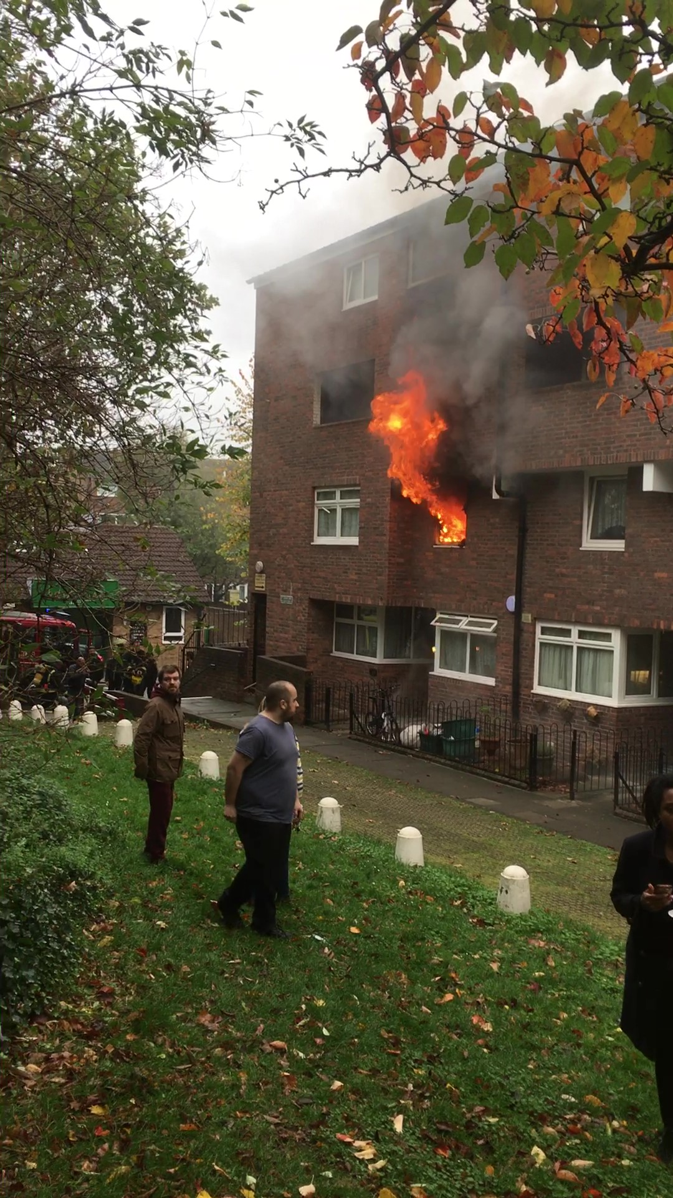
DON’T ALLOW YOURSELF TO BECOME A VICTIM!!

Our thanks goes to Annette Mencke who provided the below decorations for the Co-Op Garden – which I am sure you agree look lovely! 
Many people myself included, will have watched with horror the dreadful fire that took hold in one of the ground floor Maisonettes along St. John’s Way. Our thanks must go to all those who played a part in ensuring that all residents of the block were accounted for, and that those who are less mobile were offered assistance to vacate their property until such time as the fire was made safe. Needless to say, the Fire Brigade were brilliant, as were the police who were in attendance. And it was a real shame to hear that someone during the chaos that ensued, took it upon themselves to slash the tires of one of the police vehicles whilst the officers attended the fire scene! Thankfully no one was hurt, and it seems the damage was mostly contained. Scaffolding has now gone up to make good the damage caused by the fire and once work to the burnt-out room is completed all will become a distant memory. Suffice to say that an incident such as this serves to make you realize how quickly fire can take hold, especially in this coming season of twinkling Christmas tree lights and candles. Please be mindful of this when burning candles or re-using old fairy lights that might not be compliant with current safety regulations.

Fire – St. John’s Way

All Cuppa with a Copper meetings are now held at the Cappuchino Café in Cressida Road, London, N19 3LB.
Dates for the remainder of this year are as follows:
November:
Friday 9th Nov - 12 noon – 1 pm
Friday 16th Nov - 12 noon – 1 pm
Saturday 24th Nov - 12 noon – 1 pm
Friday 30th Nov – 12 noon – 1 pm

December:
Wed 5th Dec – 12 noon – 1 pm
Fri 14th Dec – 12 noon – 1 pm
Thursday 20th Dec – 12 noon – 1 pm
Saturday 29th Dec – 12 noon – 1 pm

These meetings provide local people with the opportunity to meet up with Officers from the Hillrise Local Police Team

Cuppa with a Copper – Autumn/Winter 2018 Dates

Thought with the onset of the holiday season looming it is a good time to provide you with some useful telephone numbers:
In an Emergency please call the Co-Op Emergency Mobile
On: 07852 765 145
Holland Walk AHO – 0207 527 7480
LBI Main Switchboard – 0207 527 2000
ASB Messaging Line: 0207 527 7272
Noise Patrol (Night) – 02075273229
Noise Patrol (Day) – 0207527 3231
Home Ownership (LBI) – 0207 527 7715
LBI Repairs Line – 0800 694 3344
Thames Water – 0845 920 0800
Gas Emergencies (Transco) – 0800 111 999
Islington Police Station – 0207704 1212
Hill Rise Police (local) 0208 345 0558

Useful Telephone Numbers –

CALLING ALL LEASEHOLDERS
Don’t forget if you are unhappy with your service charges and wish to take independent advice you can contact ‘LEASE’ . The Leasehold Advisory Service, is a non departmental public body funded by Government to provide free Legal advice to Leaseholders on the law affecting residential leasehold email: http://www.lease-advice.org

Page 2 of 3

Elthorne 1st Newsletter
CO-OP MEETING DATES - 2019
MANAGEMENT MEETING DATES
Wednesday 16th January 2019 , Wednesday 13th March, Wednesday 17th April, Wednesday 12th June, Wednesday 17th July, Wednesday 14th August, Wednesday 16th October 2019, Wednesday 13th November 2019
GENERAL MEETING DATES 2019
Wednesday 20th February 2019
Wednesday 15th May 2019
Annual General Meeting Wednesday 18th September 2019
Wednesday 11th December 2019

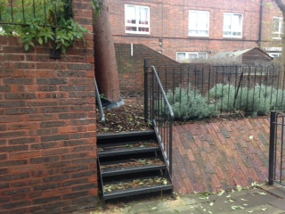

We have been advised by the Project Manager for Islington in connection with the Cyclical Maintenance Programme that this has now finalised and as from the 19th October 2018, entered the 12 month defects stage. I have to say this news was met with some concern by members of the Elthorne 1st Co-Op Management Committee, in particular because the feeling amongst committee members is that some of the work leaves a lot to be desired. We have entered discussion with Mears to highlight particular areas of concern and would welcome

Cyclical Maintenance

Elthorne Pride

HOME OWNERSHIP SERVICES

222 Upper Street

London

N1 1XR

Tel: 020 7527 7715

Email:homeownership@islington.gov.uk

‘HAVE YOUR SAY!’

Cyclical Maintenance End

WORD FROM THE CHAIR – SANDI PHILLIPS
Dear All,
As you may be aware, Lorraine will be leaving Elthorne 1st Tenant Co-Op. I am sure you will join me in wishing her the best for the future. Lorraine has been with the Co-Op for 21 years and has seen many tenants come and go. Not only has she been a part of people’s lives dealing with queries, she has been a friend and has always got time for a coffee and a chat when all we need is a friendly ear. Lorraine on behalf of the Committee & Residents Thank You for your support. We will miss you!!
Page 3 of 3

The return to the Co-Op office of the Satisfaction survey forms distributed to all residents last week (apologies for the poor setting out of these – they looked fine prior to going out to print!) If you haven’t already done so, you have until Friday 16th November to return these to the Co-Op and hopefully we will be able to use comments from these to steer our discussions with both Islington and Mears. I am advised by LBI’s project manager that invoices for these works are likely to be out in 12 months.

[Type a quote from the document or the summary of an interesting point. You can position the text box anywhere in the document. Use the Drawing Tools tab to change the formatting of the pull quote text box.]
We are pleased to report that Elthorne Pride has definitely hit the road running. It provides great opportunities to local residents along with Great Days Out to be enjoyed:
The following are just a couple of what’s on offer:
Thursday 29th November 2018 – ‘Let’s Get Started’ is a free information session about the introduction of Universal Credit. The session is aimed at recent or long term unemployed, part time workers or anyone confused about what support is on offer.
Sat 1st December 2018 – Day trip to Bath – likely to be popular so book early
If you are interested in either of the above contact 0208 017 2205 or go to events@elthornepride.org.uk

