May 2018



**ELTHORNE 1ST TENANT CO-OP LIMITED**

Data Protection and how we handle your personal information

Informational privacy (Data Protection) is the ability of a person to control, edit, manage and erase information about themselves and to decide how and to what extent such information is communicated to others. Intrusion can come in the form of collection of excessive personal information, disclosure of personal information without consent and misuse of such information.

Dear Elthorne 1st Resident,

**Elthorne 1st Tenant Co-Op** is partnered with the London Borough of Islington and both organisations are signed up to an Information Sharing Agreement (ISA). This sits underneath the overarching Information Sharing Protocol (ISP) which is an initiative that allows both parties to pool or link sets of personal data. The sharing of relevant and appropriate information between both parties is necessary in order to allow Elthorne 1st Tenant Co-Op and LBI to adequately perform service delivery designated to either party under the Modular Management Agreement (MMA).

The Coop has a lawful basis for processing personal data. Collecting and using certain types of information about individuals it communicates with in order to effect service delivery and manage rent accounts is essential. Personal information will be handled properly however it is collected, recorded and used – whether on paper, electronically, or recorded on other material - and there are safeguards to ensure this. The organisation regards the lawful and correct treatment of personal information by it as very important to effective operations, and to maintaining confidence between Elthorne 1st Tenant Co-op Limited and those it communicates with.

Data Protection is changing

As a result of the much publicised data breaches of multi-national organisations such as Yahoo, Google and Facebook, the Data Protection Act 1998 will be replaced by the General Data Protection Regulation (GDPR) which is a piece of EU legislation passed by the European Parliament in 2016, and is enforceable in all EU countries from May 25 2018, even after the UK leaves the EU.

GDPR is the biggest change to UK data privacy law for 20 years and will be introduced for the purpose of harmonising data protection across Europe and to address the technological and societal changes since the Data Protection Act came into force. The need to know must be balanced with the right to privacy, so GDPR creates a single set of rules that better protects personal information for people across the EU and organisations must review how they manage personal data.

GDPR will work in much the same way as the Data Protection Act, but with more stringent permission requirements than before. GDPR aims to make it simpler for people to control how companies use their personal details. There are six principles and these focus on the intent with which any data is accessed, harvested or retained. This new legislation means that all companies including TMOs are required to comply with GDPR even if the amount of data held is minimal.

The 6 principles of GDPR

The Co-op handles data in accordance with the following six GDPR principles:

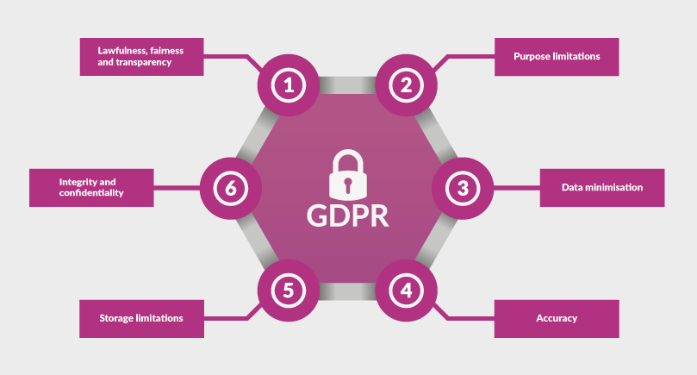

1. Lawfulness, fairness and transparency

Transparency: Tell the subject what data processing will be done.   
Fair: What is processed must match up with how it has been described.  
Lawful: Processing must meet the tests described in GDPR.

2. Purpose limitations

Personal data can only be obtained for “specified, explicit and legitimate purposes”. Data can only be used for a specific processing purpose that the subject has been made aware of and no other, without further consent.

3. Data minimisation

Data collected on a subject should be “adequate, relevant and limited to what is necessary in relation to the purposes for which they are processed”.  
I.e. No more than the minimum amount of data should be kept for specific processing.

4. Accuracy

Data must be “accurate and where necessary kept up to date”

5. Storage limitations

Regulator expects personal data is “kept in a form which permits identification of data subjects for no longer than necessary”.  
I.e. Data no longer required should be removed.

6. Integrity and confidentiality

Requires processors to handle data “in a manner [ensuring] appropriate security of the personal data including protection against unlawful processing or accidental loss, destruction or damage”.

What is personal data?

Personal data (Personally Identifiable Information or PII) is any data which relates to an identifiable living individual.

Privacy Notice

Elthorne 1st Tenant Co-Op Limited *ensures your personal information will be kept private.*

*The data held comes from various sources, e.g. the data subject, London Borough of Islington, or Department of Work and Pensions (DWP) and is often limited to name, address and contact details.* *The Coop does not own this data, you do. The Coop only processes your data lawfully in order to operate effectively.*

*Under the Information Sharing Protocol (ISA) between* Elthorne 1st Tenant Co-Op Limited *and LBI, there is a legal justification in holding certain personal information about residents (specifically, contact details) as there is the obvious requirement for joint-working between* Elthorne 1st Tenant Co-Op Ltd*, LBI and their contractors to perform certain functions under the obligations of the Modular Management Agreement ( MMA). This includes the Co-op’s Out of Hours Service. Such data is classed as ‘vital interest’ and will be retained unless erasure is requested. You do not have the right to restrict the ‘lawful processing’ of your data, but you can request that it is erased in accordance with the General Data Protection Regulations (GDPR 2016). Data can be erased or over-written as fresh data replaces it.*

*On occasion, your contact details will be passed to our contractors to facilitate service requests. All contractors are required to sign a Data Protection Contract.*

*Any personal data held by* Elthorne 1st Tenant Co-Op *is not accessible by Committee members and access to data is strictly on a need-to-know basis.*

*Computers are pin and or password protected, data which is backed up manually is encrypted, and data backed up to the cloud is stored only on UK based servers.*

*Paper based files are kept under lock and key and only accessible by the Manager or Bookkeeper.*

Elthorne 1st Tenant Co-Op *will review its data protection procedures on at least an annual basis to ensure it accurately records:*

*• The purposes for which personal information is held*

*• Who the data subjects are we are holding personal information on*

*• The types of data e.g. emails, letters, housing benefit information,we are holding*

*• The sources of the personal information we are holding*

*• The recipients of the personal information we are holding*

Elthorne 1st Tenant Co-Op *ensures:*

* *that the rights of individuals about whom information is held can be fully exercised*

*under General Data Protection Regulations (GDPR).*

* *the right of access to one’s own personal information via Subject Access Request*

*procedures.*

* *the right to prevent processing in certain circumstances, the right to correct rectify, block or erase information which is regarded as wrong information.*
* *take appropriate security measures to safeguard personal information:*

1. *data will kept private, and not transferred to a country or territory outside the European Economic Area (EEA).*
2. *that cloud based data is held only on UK based encrypted servers.*

*Exemptions*

*In addition to the data sharing agreement with the London Borough of Islington,* Elthorne 1st Tenant Co-Op *will comply with requests to share your data with law enforcement agencies.*

*The Data Protection Bill allows for the disclosure of personal data if such disclosure is necessary for:*

*• the prevention of crime*

*• the apprehension or prosecution of offenders*

*• the assessment or collection of any tax or duty or similar*

*and*

*permits the disclosure of personal data if such disclosure is:*

*• necessary for the purpose of or in connection with any legal proceedings of any nature*

*• necessary for the purpose of obtaining legal advice*

*• necessary in order to establish, exercise or defend any legal right*

*Consent*

*Consent to process data is granted only on approval from the data subject. e.g. on tenancy sign-up.*

*Children’s data will not be processed without explicit consent from a parent or legal guardian.*

*Access to your personal data*

*You have a right to access the data that* Elthorne 1st Tenant Co-Op *holds about you in accordance with the General Data Protection Regulation (GDPR 2016).*

*You have a right to request that it is updated, minimal and erased if you so wish. Anyone wishing to access their data will be required to request a Subject Access Request form in writing via post or email. The form will be provided in the same manner, and completed Subject Access Request (SAR) forms will be processed within 30 days.*

*Written requests for Subject Access Request (SAR forms) should be addressed to:*

*The Manager/Data Protection Officer*

# **Elthorne 1st Tenant Co-op Limited**

**158 St. John’s Way**

**London**

**N19 3RL**

Or via email to: info@elt-1st.demon.co.uk

*Data requested by you using Subject Access Request (SAR forms) will be provided by* Elthorne 1st Tenant Co-Op *free of charge initially.*

*Repeated or unreasonable requests e.g. data unchanged, may be declined or if processed subject to charges, all subject to GDPR 2016.*

End.

Compliance

1. The Manager has overall responsibility for data protection within the Co-operative.

2. All Committee members have a responsibility to fully comply with the requirements of

the GDPR and this policy.

3. Serious breaches of the GDPR policy and/or procedures will require the member(s) responsible to withdraw or be dismissed from the Committee.

4. Serious breaches of the GDPR Policy and/or procedures by a member of staff will require the individual(s) responsible to resign or be dismissed.

5. Serious data breaches will be reported to the Information Commissioners Office ( ICO) within 72hrs of discovery.

Equal Opportunities

The Co-op will ensure that in implementing its GDPR Policy it will not unfairly discriminate against any individual, household or group on the grounds of sex, marital status, race, disability, age, sexual/gender orientation, language, social origin, religious beliefs or political opinions.

Addendum:

Electronic data which relates to the personal information of any resident is only accessible by the Manager and Bookkeeper and is password protected/encrypted. The Bookkeeper does not have comprehensive access to all data which is held, and is only granted access on a need-to-know basis via the Manager.

CCTV footage is only accessible by the Manager and will only be released to relevant third parties in accordance with the organisation’s CCTV Policy.

Data which is held on paper is kept in a locked filing cabinet in a locked office away from general access. Although this data is not reviewed regularly, any such data which is no longer required is shredded as is every-day administrative data which is not considered necessary for filing. Paper based data which is no longer required and contains any information which may be considered sensitive or confidential to either the Co-op or its residents, is also shredded. This can be on a daily basis as and when necessary, but usually when reviewed annually.

Committee members, including Officers, have no access to any personal data held by the organisation. Individual cases are occasionally discussed at Committee meetings if this is relevant to the agenda, for example when a tenant is in rent arrears, but at no time are individuals identified. Any personal information relating to any individual is only relayed to the Committee on a strict need-to-know basis. All Committee members are aware that such agenda items are not for discussion outside Committee meetings as they have all signed the Code of Conduct.

Contractors are required to sign a Data Protection Contract.

The Committee