ELTHORNE 1ST TENANT CO-OP ANNUAL REPORT | 17th September  2018
 |  | Annual Report

Contents

- Foreword 2
- Introduction 4
- Value for Money 6
- Home Improvement 7
- Neighbourhood and Community 8
- Tenancy Update 8
- What Next – value for Money 9
- Our Commitment 9
- Monitoring The Offers and Poor Performance 10
- Staffing commitments 10
- Conclusion 11

ELTHORNE 1ST TENANT CO-OP ANNUAL REPORT

FOREWORD

- Our Annual General Meeting

A very big welcome to all residents to our 2018 Annual General Meeting. We begin by thanking you all for supporting the Co-op over the last year. Without the support of our residents the Co-op would cease to exist so we very much value your input.

Those of you who have attended the AGM before will be aware it is at the AGM that existing members of the management committee step down and new members are voted in or existing committee members are re-elected.

Before the main business of the AGM commences heralding another year in the life of the Co-Op (assuming the continuation vote is in favour of the Co-Op continuing) we take this opportunity of thanking all our current committee members for their continued support throughout the year. They work hard behind the scenes to ensure the Co-Op runs as efficiently as possible and without their help and support this wouldn’t be possible.

- Overview

The onset of 2018 heralded some significant changes in the way all companies do business. In particular surrounding the way in which personal information is held and dealt with. I am sure you are all aware of the term GDPR (General Data Protection Regulation). The introduction of GDPR has dominated the internet over the past 8 months or so and the Elthorne 1st Co-Op along with all other companies who hold personal information has had to ensure we are compliant. This has necessitated a lot of work for the Co-Op to ensure that all data held is up to date and that our office (which as most of you will be aware is a flat converted into an office) is set up in such a way as to ensure the security of any information held. As a result of this we now sport a new meeting room which allows meetings to be held totally independent of the Co-Op. The Elthorne Co-Op strongly believes in the importance of a resident lead approach to maintaining the estate. Over the course of the last few years we have worked hard to improve areas that were previously looking very neglected. We recognise that there is still room for improvement and because of this we have worked closely with Islington during the recent Cyclical Maintenance Programme flagging up areas that have been missed and/or unsatisfactory workmanship. On more than one occasion this has meant going into battle with Islington in an attempt to ensure the work is done to an acceptable standard However what we do ask is that residents bear with us because whilst we work closely with Islington it is they who determine the time frame of development and/or improvement programmes and the length of time it takes to implement many of these improvements is very often a source of frustration to the Co-Op as well as residents.

The other big news stories for the year have been the proposal to build on the site of the sunken football pitch. The Elthorne Co-Op engaged at an early stage with the Project Manager of the scheme to ensure that Residents views were heard and considered. In many respects it could be argued that the developers already had a clear idea of what they wanted but we have won some small victories because the seating area that was proposed to the rear was removed prior to submission to planning in response to concerns raised by residents about this acting as a magnet for antisocial behaviour.

More recently of course is the news of the proposed night shelter by a Charity know as ‘Shelter from the Storm’ in the old Nisa Store (next to the Holland Walk Area Housing Office). This planning application met with a lot of opposition and the Elthorne 1st Co-Op took an active role in keeping its residents informed with important dates should they wish to either protest/support the application. However we understand at a Full Planning meeting held on Thursday 6th September the Planning Application for Change of Use was agreed.

The other big thing on the horizon for the Elthorne 1st Co-op is the setting up of our Neighbourhood Watch Scheme. Thanks goes out to all involved in the groundwork for this scheme which has necessitated a lot of effort to get off the ground. The Information evening scheduled for the 26th September 2018 (look out for the flyers and an application to join form coming soon) which doubles as the launch of the scheme, we hope will be well attended by residents interested in getting involved and we look forward to seeing you there.

Once again thank you for your support over the last year.

The Co-Op Office

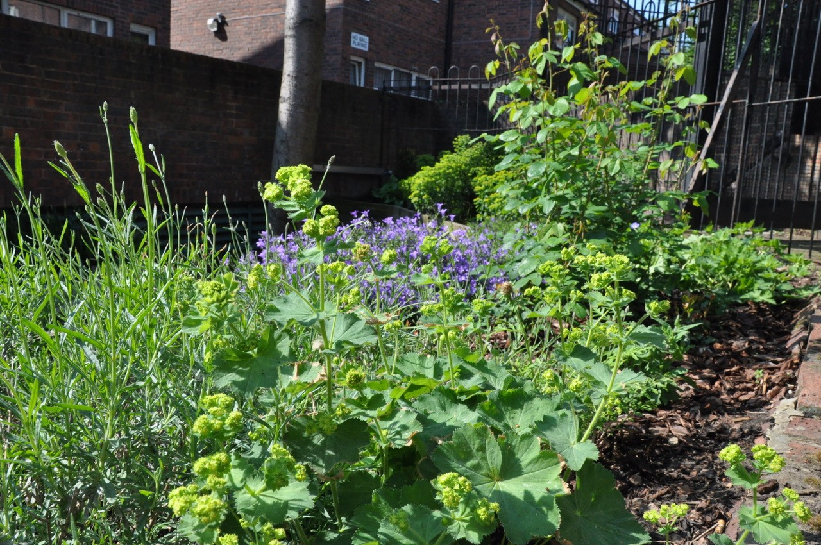

INTRODUCTION

About the Tenant Management Co-op (Elthorne 1st Tenant)

The TMC has a close working relationship with the Council, although it is a completely separate entity.

The TMC is managed by a Management Committee comprising currently of eight elected tenant and leaseholder members. The rules allow for up to a maximum of 15 members. The Chair of the Board is Sandi Phillips.

The Committee meets on a regular basis to monitor how well the TMC is doing, agree plans for the future and decide on policies. The Office Manager, Lorraine Welland, appointed by the Management Committee, has overall responsibility for the successful operation of the TMC, and for ensuring that the Management Committee’s decisions and policies are carried out.

The Council pays a management fee to the TMC to enable it to carry out its functions. For the coming year the allowance from Islington is set at £154,300.00. We listen to and take on board resident’s comments and concerns about all work carried out by the Co-op in our bid to ensure value for money with good quality and courteous workmanship.

Value for Money

Sometimes we find ourselves in a difficult position because we need to ensure any contractors we use have all the relevant insurance documentation in place, but of course this all comes at a cost. This means that whilst we look for value for money in every project we undertake, we also have to give consideration, to whether that Contractor – although perhaps offering the most competitive price – is able to meet the strict criteria laid down for those organisations like ourselves in charge of public funding.

How are we performing? - Estate Repairs Carried out by Elthorne 1st Co-Op

Over the course of the year 2017/2018 (31st March 2017-31st March 2018) The Elthorne 1st Co-Op carried out 95 Repairs. These numbers relate to the number of jobs carried out and not the number of visits, which is much greater because some jobs require multiple visits. This number does not include those jobs reported through the Co-Op office that are the responsibility of LBI and their contractors.

Improvements –

This year the Elthorne 1st Co-Op have continued to build on some of the improvements carried out in previous years. The garden in the centre of the Duncombe Road walkway we hope you will agree is now a delight, along with the raised garden area which is also looking lovely.

Tarmac in Partington Close has now been finalised. We recognise that this wasn’t without its problems (we had to ask the contractors to return on 3 separate occasions). However, we feel the last attempt has bought it up to a satisfactory level, albeit that it would have been helpful had this been the case from the start.

GDPR Preparations – As touched upon in our overview at the beginning of this report the Co-Op have put a lot of time and effort this year into ensuring we are compliant with new GDPR regulations that came into force in May of this year. In order to fully comply it was considered better to have a separate meeting room in order to be able to lock away any personal information held. The result of this is a fully independent meeting room that can be used to accommodate not only Elthorne 1st Co-Op meetings but going forward can facilitate Neighbourhood Watch Information meetings and other useful group meetings for residents of Elthorne 1st.



Neighbourhood Watch Scheme –

As touched upon in our overview at the beginning of this report. The Co-Op has worked closely with one of our Committee Members Annette Mencke and the Local Neighbourhood Police Team in an attempt to get this scheme off the ground.

Mick Murray (who unfortunately has relocated elsewhere) from the Hillrise Neighbourhood Police Team attended our AGM last year and kindly outlined to residents the benefits of setting up such a scheme. Building on this we arranged a meeting for early January for residents to attend to show their support for the scheme and to brief them on how it could work. We are pleased to announce that the scheme has now been registered and an Information evening has been arranged for Wednesday 26th September in the Co-op office to launch the scheme. If you are interested in joining the scheme information packs will be distributed to all residents. Our thanks must go to Annette Mencke who has put significant effort into this along with the ‘Elthorne Pride’ who provided £500 towards stickers and signs.

Estate Repairs – London Borough of Islington

In addition to the repairs carried out by the Co-Op. Elthorne 1st facilitates repair orders to Islington Council. This way the Co-Op can keep track of job numbers (should it be necessary to chase), and provide background information should it be necessary.

Paving repairs and repairs to fabric of the building are the responsibility of Islington Council but the Co-Op facilitates these repairs by quarterly meetings with Estate Services at Holland Walk to highlight any areas of concerns.

FINANCE

Over

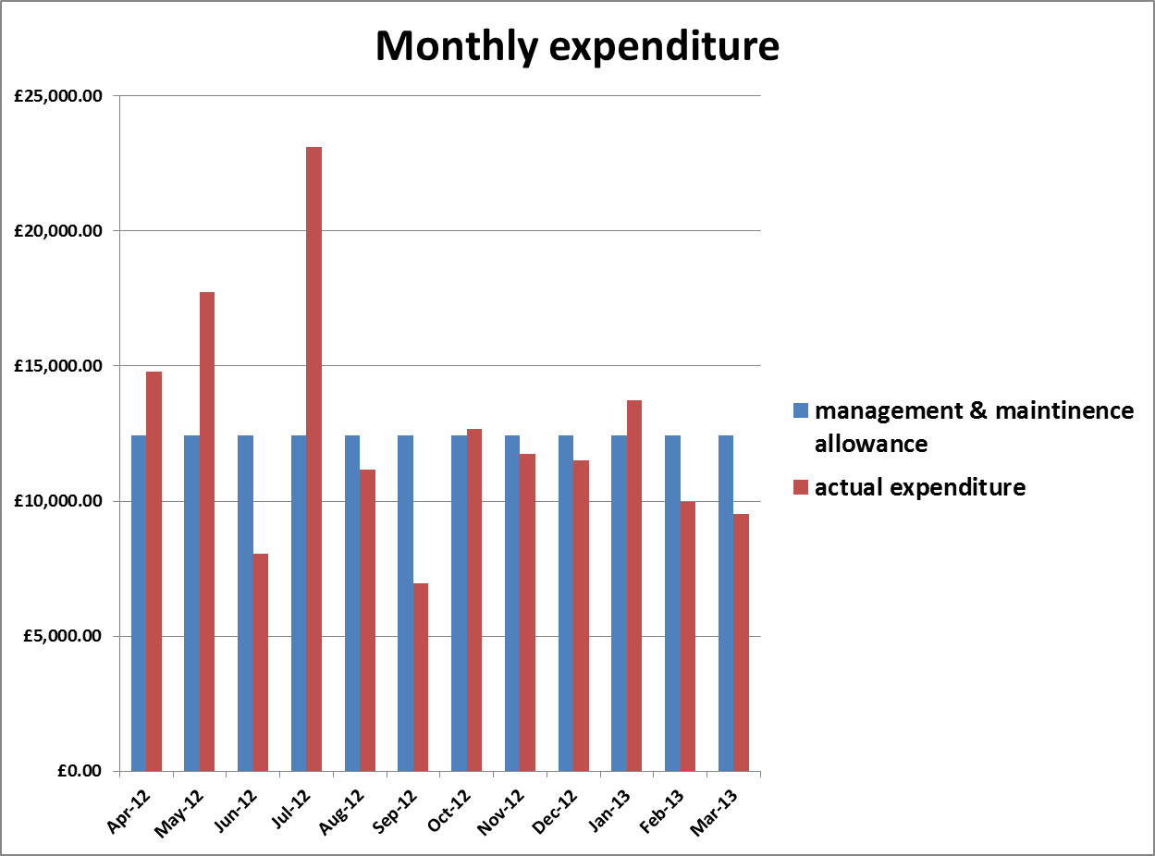

The breakdown for 2012/13 expenditure was as listed below:

Staff Costs £65,796.00

Repairs & Maintenance £19,528.00

Re-Let Repairs £4,452.00

Insurance £3,536.00

Rent & Rates £2,870.00

Heat & Lighting £400.00

Printing & Stationary £2,168.00

Telephone & Postage £1,375.00

Audit & Accountancy £6,433.00

Furniture & Equip £303.00

Fixtures & Fittings £13

Computer Equipment £1,413.00

Bank Charges £1,878.00

Equipment Maintenance £489.00

Office Costs £8,913.00

Subs & Publications £180.00

Social Committee £125.00

Bad & Doubtful Debt £5,772.00

Void Losses £5,679.00

For Comparison The Co-Op spent the following over the year 2011-12

Staff £65,595.00
Training £350.00
Repair & Maintenance £25,632.00
Communication £1,217.00
IT £3,386.00
Re-Let Repairs £4,720.00
Audit & Accountancy £6,370.00
Insurance £3,326.00
Rent & Rates £1,185.00
Heat & Light £560.00
Printing & Stationary £994.00
Bank Charges £1,779.00
Office Costs £5,935.00
Subs & Publications £180.00
Bad & Doubtful Debt £3,379.00
Void Losses £4,559.00

Total Expenditure £130,886.00

- HOME IMPROVEMENTS

As first reported in last year’s overview we continue to encounter problems with water tanks in properties. We have now replaced a large number of tanks which were found to be leaking through rust holes which form on the side of the tank and start to weep eventually undermining the integrity of the whole tank. Because of the sheer numbers we are faced with and the fairly high cost of replacement (the labour charge for replacement is high due to difficulties with access) we are adopting a reactive approach. When properties become void we as a matter of course replace the tanks.

We have recently carried out work to gutters in St. John’s Way and have work earmarked for Partington Close. The work carried out to St. John’s Way proved the guinea pig for further works by the same contractor. The biggest stumbling block for the Co-Op when dealing with repairs and maintenance to guttering is access. Scaffolding comes at an extremely high cost and ever mindful of service charge costs for Leaseholders and Freeholders we try where possible to ensure costs are kept to a minimum, whist still complying with health and safety regulations. It has been agreed that we will use a mixture of ladders (where practicable) and scaffold towers and we hope with the use of both we will be able to keep the cost to an acceptable level.

We have through pressure from the Co-Op, got Islington Council to set aside funding for an upgrade of the enclosed garden area on the Duncombe Road walkway. We are disappointed that the work hasn’t commenced prior to this AGM but have been assured by Islington that the funding is ring-fenced and that work is to commence shortly.

- NEIGHBOURHOOD AND COMMUNITY

Over the course of last year and this, we have looked at replaced and upgraded a number of lights throughout the co-op both inside and outside of blocks.

In response to resident concerns raised at a recent general meeting we are looking into the prospect of installing CCTV cameras. We are currently obtaining quotes and taking advice on the best type of system for the Co-Op giving consideration to keeping costs to at an acceptable level whilst providing a system that is worthwhile and effective.

In order to better communicate with our residents we have over the year 2012-13 installed notice boards in all our blocks.

‘BIG LOCAL’ LOTTERY FUNDING

Many will have seen the press reports surrounding the One Million pound lottery funding that has been secured for the Elthorne Estate. This money is to be released over a 10 year period primarily to support local community groups. The Co-Op has from the beginning taken steps to ensure we are represented on the ‘Big Local Panel’ to facilitate any of our residents who might wish to become involved or start up a community group.

6. TENANCY UPDATE

TENANCY – allocating homes in 2012-2013. We had 4 empty properties. We endeavour to re-let all properties within 6 – 8 weeks of their becoming vacant however because we have to advertise and allocate all our empty properties through London Borough of Islington it is sometimes difficult to keep to timeframes laid down by Co-Op.

RENT ARREARS – (Have remained pretty steady throughout the year 2012-2013). However with the proposed national changes to the benefit system we anticipate there may well be a spike in arrears in the early part of 2013/2014 budget. We intend to work closely with all those tenants with arrears and draw up a payment plan that will be closely monitored.

TENANT INVOLVEMENT – Over the year the Co-op worked with tenants and leaseholders in establishing new ways aimed at improving services.

7.WHAT NEXT?

Value for money

Achieving value for money is one of the key aims of the Co-Op. We constantly review our services to ensure that the contractors we use offer a good and courteous service and provide value for money.

8.OUR COMMITTEMENT – ELTHORNE 1st Offers

Local offers are the way in which we tailor our services based on what RESIDENTS want. From the work that we have done already we have a very good idea of many of the areas of work that you want us to do and we will come back and talk to you again before April 2014 when our local offers must be in place.

Our local offers

You told us you wanted the Co-op to look into the possibility of installing CCTV cameras:

Our offer is to obtain quotes and advice on the best type of CCTV for our needs and to have this installed throughout the Co-Op.

You told us that you were more concerned about the condition of the enclosed garden along the Duncombe Road walkway.

Our offer is to ensure that funding set aside by Islington, following pressure by our Co-Op, is used to upgrade and improve this space over the remaining summer months. In the interim (whilst we await regeneration of the garden by Islington), we have commissioned a big tidy up of the garden to ensure the area doesn’t get too overgrown.

You told us that antisocial behaviour in the form of youths congregating on walkways is an issue.

Our offer is to work with you to try and resolve these issues; we undertake to liaise with London Borough of Islington Anti-Social Behaviour Team and the Neighbourhood Police to adopt a joined up approach to monitoring our part of the estate.

You told us that some of you wish to receive notification of General Meeting and associated paperwork via e-mail.

Our offer is to collect e-mail address from as many of our residents as we can and provide this service to those who request it.

You told us you would like the aesthetics of the estate improved.
We are beginning a programme of external painting to replace the white lines on all steps and re-painting of external cupboard doors.

You told us Leaseholders needed support when dealing with Islington Council.
Our offer is to support our Leaseholders by facilitating and notifying our residents of meetings in connection with works planned by Islington Council.

9.MONITORING THE OFFERS AND POOR PERFORMANCE

It is proposed that monitoring the offers will be undertaken through the year by existing resident engagement mechanisms.

There are many ways to deal with poor performance; this can include the most usual method of expecting the organisation managing to provide a clear explanation as to why the target has been missed through an exception report, and to provide an action plan to remedy the situation.

This information is made available to the appropriate meeting where further questions are asked

10. STAFFING

Caretaking Services – The Co-Op currently has a temporary Caretaker Thomas Wickham who has been with us since early in the year. It is with regret that the permanent caretaker we employed didn’t work out and the co-op was forced to revert back to using the temporary caretaker. This is an area that is currently under review. However we thank Thomas who has been of great help to us over the months since Christmas and continues to be so.

We undertook last year to carry out a deep clean to all chute rooms and areas of the block with heavy usage. We haven’t been able to fulfil this offer due to problems with the caretaking however we are mindful of this promise and intend to carry out this work in the current financial year.

11.CONCLUSION

We have the opportunity through this annual reporting to provide you with information about your housing service. We hope that you will share your thoughts and ideas about this report with us so that we can further improve our service.

To sum up our thanks goes to all those individuals who have helped support the Co-Op throughout the year and who continue to work tirelessly to ensure the Co-Op continues to provide a good service to all.

Contact us at:

ELTHORNE 1ST Tenant Co-op

Lorraine Welland, Office Manager
Sandi Phillips, Chair
Tim Bleach, Treasurer
Lesley Carter, Secretary
Margaret Deasy, Committee Member
Christine Warren, Committee Member
George Smith, Committee Member
Wesley Gilead, Committee Member
158 St Johns Way, London, N19 3RL
Telephone: 020 7263 5756
Email: info@elt-1st.demon.co.uk

